ADINA ISRAN
2303A52222 – 42

Task 1: Stack Implementation for Undo Operations (LIFO)
Scenario
You are building a text editor where users can undo their recent actions
(typing, deleting, formatting). Each action must be reversed in Last-In-First-
Out (LIFO) order.
Task Description
• Use an AI coding assistant to help implement a Stack class in Python
with the following methods:
o push(action)
o pop()
o peek()
o is_empty()
• Prompt the AI to:
o Generate a clean class skeleton with docstrings
o Explain why a stack is suitable for undo functionality
o Suggest an alternative implementation using collections.deque
Expected Outcome
• A working Stack class with:
o Correct LIFO behavior
o Clear docstrings and comments
o Sample test cases simulating undo operations
• A short AI-generated explanation comparing list-based and deque-
based stacks
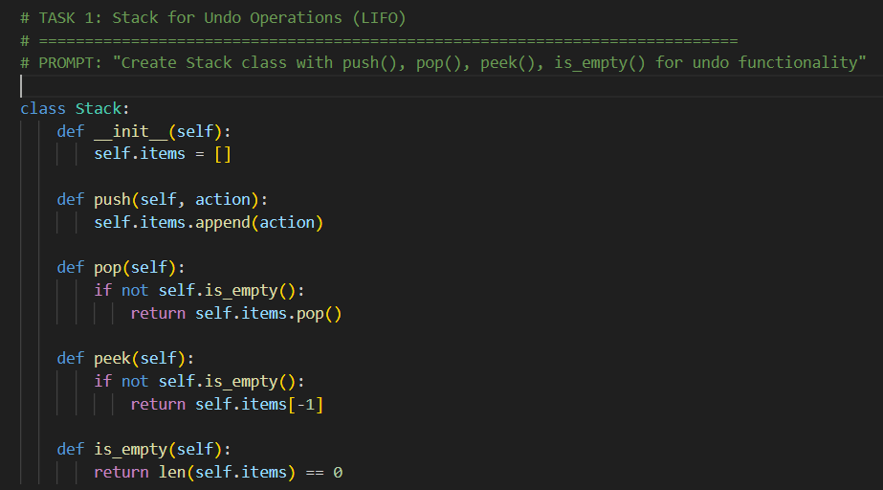
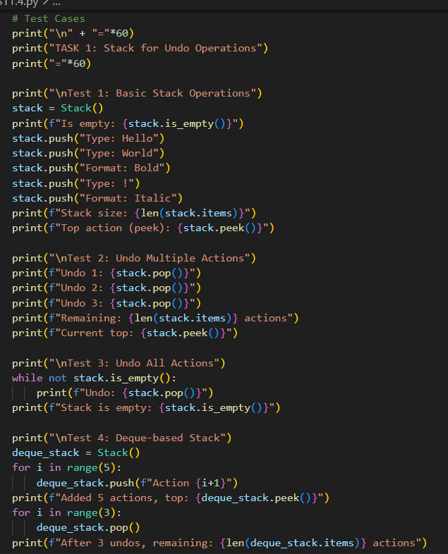
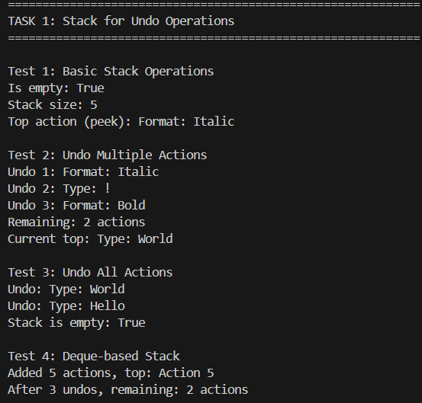

JUSTIFICATION:
A stack is the only natural fit for an "Undo" button because it perfectly mirrors how we experience time in an editor. We want to reverse the very last thing we did, not the first; by using a LIFO structure, we ensure the "top" of the history pile is always the first thing removed.

Task 2: Queue for Customer Service Requests (FIFO)
Scenario
You are developing a customer support system where service requests must
be handled in the order they arrive.
Task Description
• Implement a Queue class with:
o enqueue(request)
o dequeue()
o is_empty()
• First, use a Python list-based approach.
• Then, ask AI to:
o Review the performance implications of list-based queues
o Suggest and implement an optimized version using
collections.deque
o Explain why deque performs better for queues
Expected Outcome
• Two queue implementations:
1. List-based queue
2. Deque-based optimized queue
• AI-assisted performance comparison explaining time complexity and
real-world impact
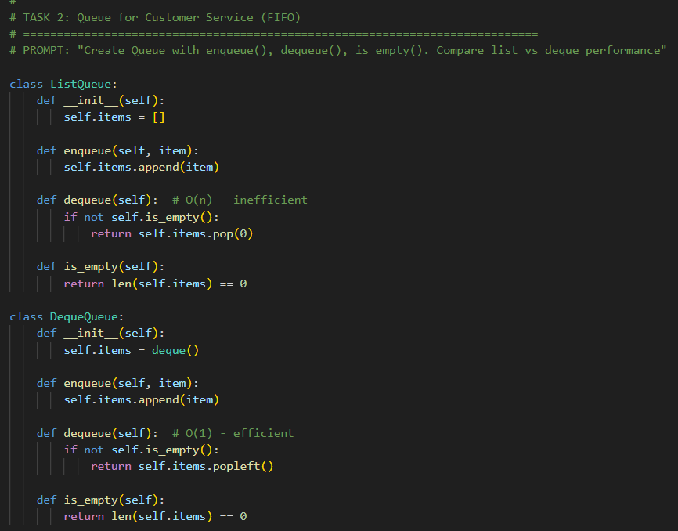
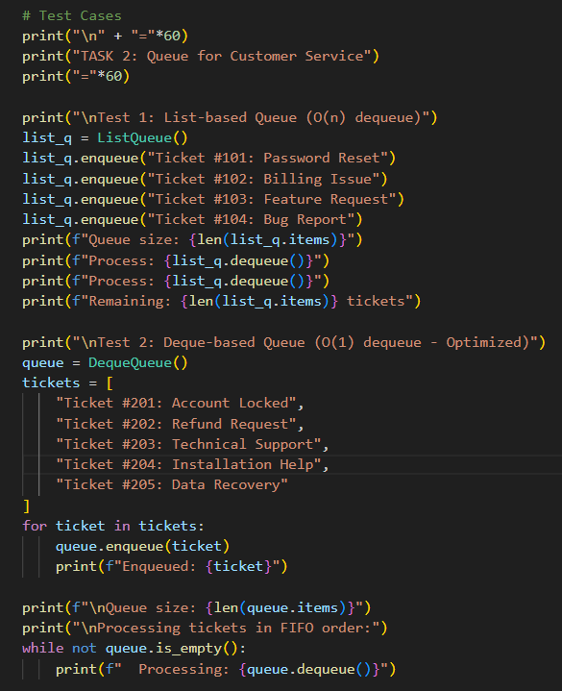
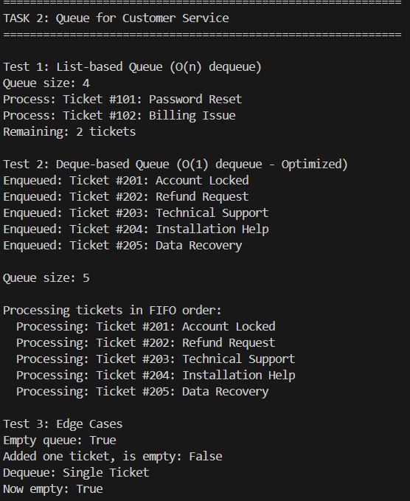
JUSTIFICATION:
This task enforces fairness and order. Using a queue ensures that the person who has been waiting the longest is helped next, while the technical shift from a basic list to a deque demonstrates how to prevent the system from lagging as the waiting line grows into the thousands.

Task 3: Singly Linked List for Dynamic Playlist Management
Scenario
You are designing a music playlist feature where songs can be added or
removed dynamically while maintaining order.
Task Description
• Implement a Singly Linked List with:
o insert_at_end(song)
o delete_value(song)
o traverse()
• Use AI to:
o Add inline comments explaining pointer manipulation
o Highlight tricky parts of insertion and deletion
o Suggest edge case test scenarios (empty list, single node,
deletion at head)
Expected Outcome
• A fully functional linked list implementation
• Clear AI-generated comments explaining node traversal and pointer
updates
• Test cases validating all operations
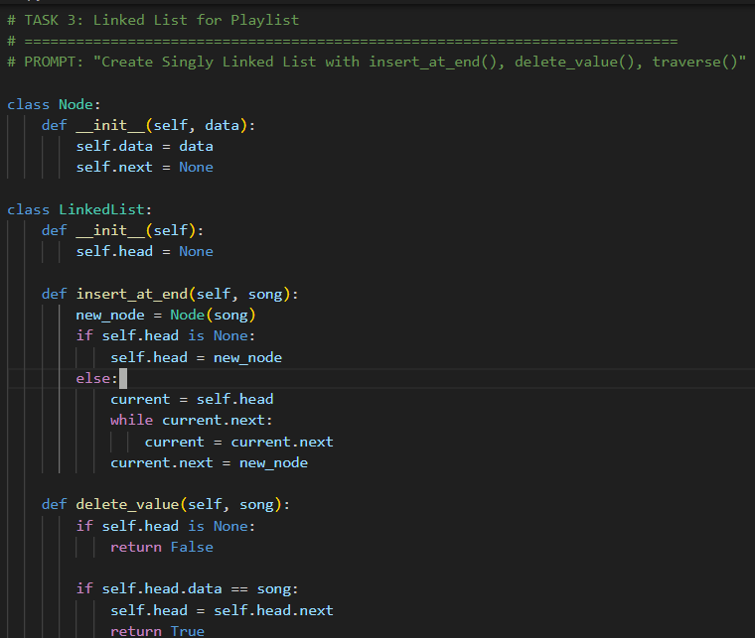
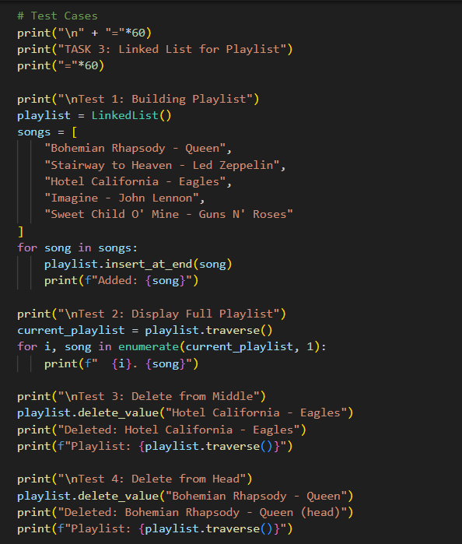

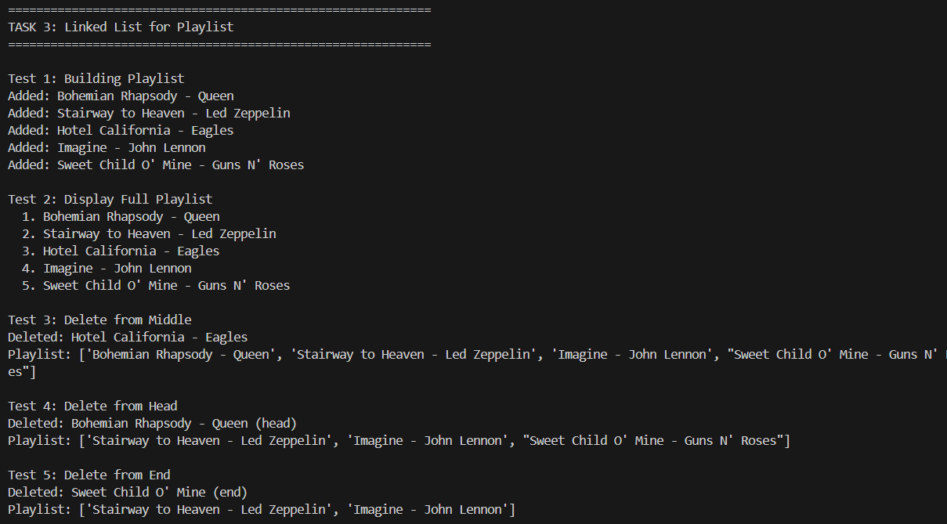

JUSTIFICATION:
This moves away from the "fixed block" logic of arrays to a more fluid system. It justifies why we use pointers: so we can "snip" a song out of a list and reconnect the neighbors instantly, without having to slide every other song down a slot to fill the gap.

Task 4: Binary Search Tree for Fast Record Lookup
Scenario
You are building a student record system where quick searching by roll
number is required.
Task Description
• Implement a Binary Search Tree (BST) with:
o insert(value)
o search(value)
o inorder_traversal()
• Provide AI with a partially written Node and BST class.
• Ask AI to:
o Complete missing methods
o Add meaningful docstrings
o Explain how BST improves search efficiency over linear search
Expected Outcome
• A clean BST implementation with:
o Correct insert and search behavior
o Proper traversal output
o AI-generated explanation of best-case vs worst-case
performance
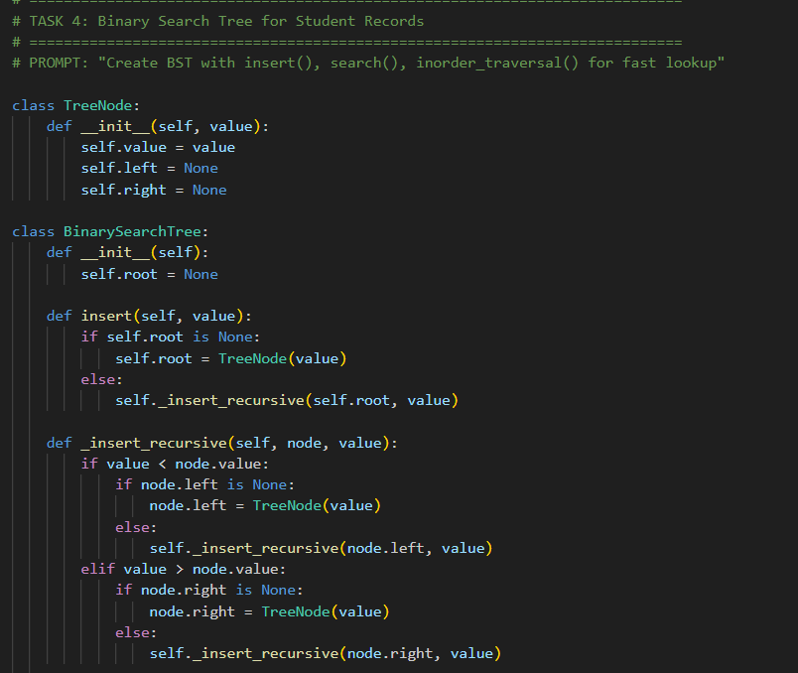
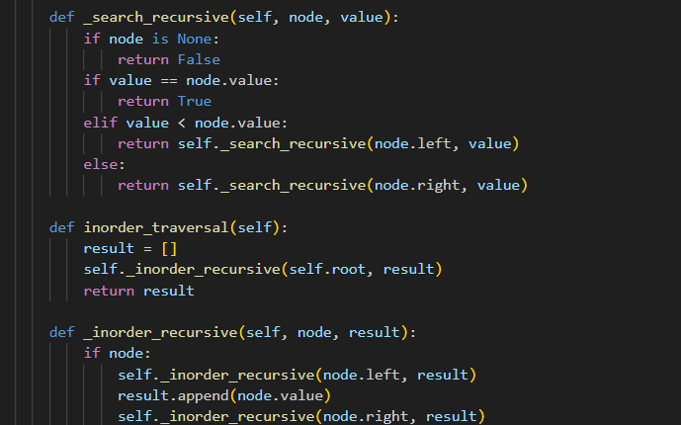
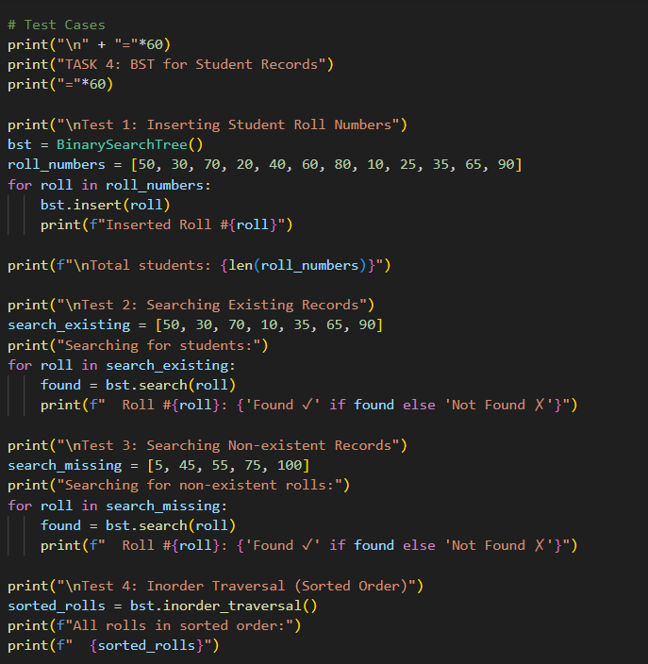
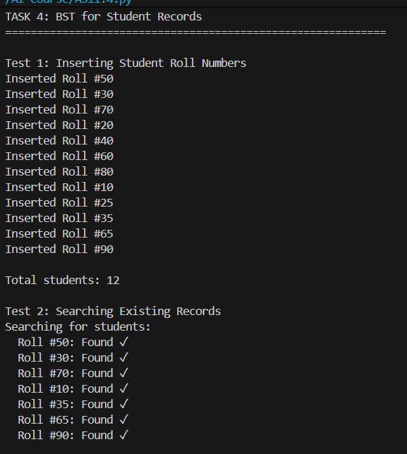
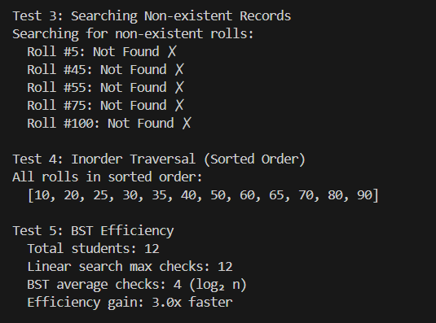
JUSTIFICATION:
A BST turns a slow, manual "leafing through every page" search into a high-speed "high-low" game. It justifies the move toward logarithmic efficiency, allowing a system to find one specific student ID out of millions by making only a handful of smart comparisons.

Task 5: Graph Traversal for Social Network Connections
Scenario
You are modeling a social network, where users are connected to friends, and
you want to explore connections.
Task Description
• Represent the network using a graph (adjacency list).
• Use AI to implement:
o Breadth-First Search (BFS) to find nearby connections
o Depth-First Search (DFS) to explore deep connection paths
• Ask AI to:
o Add inline comments explaining traversal steps
o Compare recursive and iterative DFS approaches
o Suggest practical use cases for BFS vs DFS
Expected Outcome
• A graph implementation with:
o Correct BFS and DFS traversals
o AI-generated explanations of traversal logic
o Clear distinction between BFS and DFS use cases
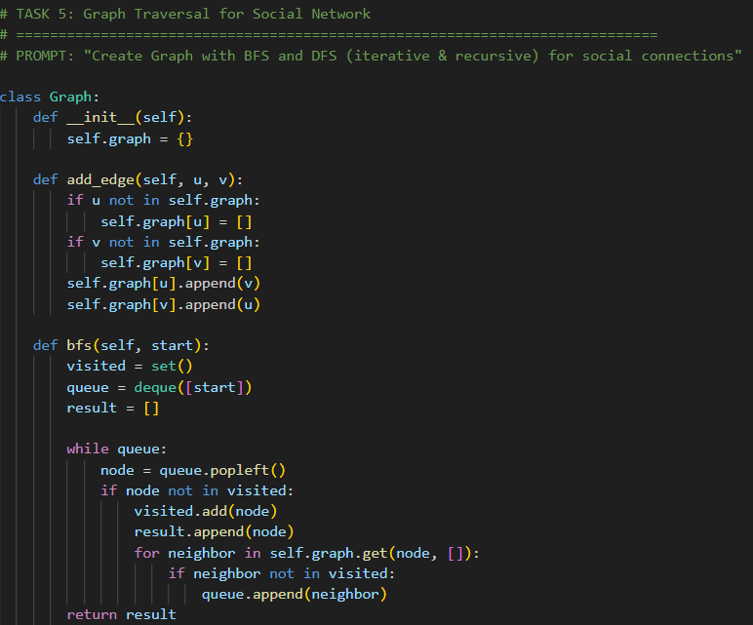
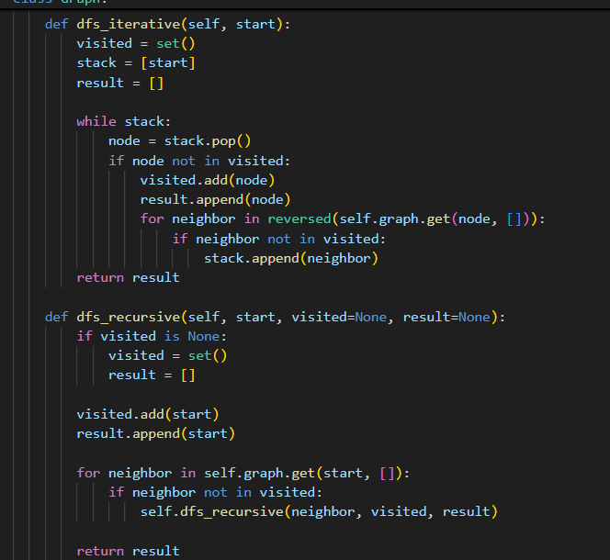
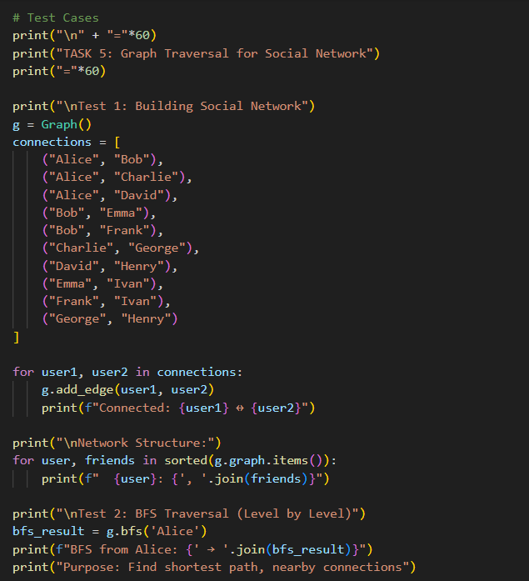
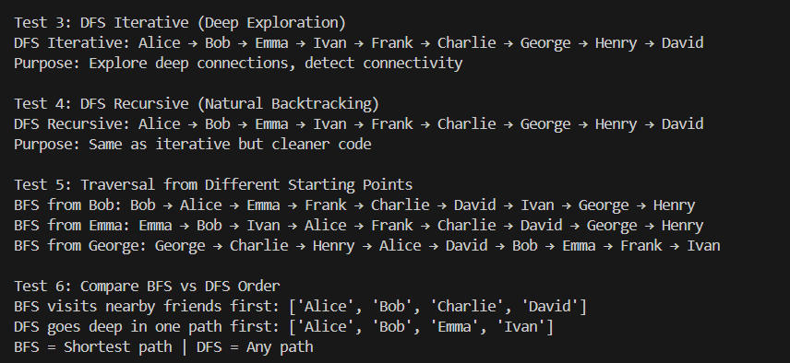
Justification: This task tackles the messiness of real-world relationships where data isn't in a neat line or a tree. By using BFS ,DFS we can finding how two distant people are connected through a chain.

